TIME SERIES DATA ANALYSIS AND FORECAST METHODS

Lecture 2
Principal characteristics of time series data

Yekaterinburg
2017
Contents

Lecture purpose 3

Lecture map 3

Part 1. Numerical characteristics of time series 4

Part 2. Correlation characteristics of time series 8

Part 3. Autocorrelation function analysis 11

Part 4. An example 13

References 17

Lecture purpose
The purpose о this lecture is to introduce the students to standard characteristics of time series, to teach them how to estimate the stochastic characteristics, the correlation functions and spectrum characteristics for any given time series. There are also some examples of application of the techniques listed in this lecture.

Lecture map

- Theoretical definitions of statistical characteristics
- Transition from ensemble averaging to time averaging
- Characteristics estimation based on one sample data
- Common definition of correlation moments
- Autocorrelation function estimation
- Correlograms and correlation tables

Part 1. Numerical characteristics of time series
By definition, the time series (TS) data is only particular selection of the stochastic variable described by its distribution function. If at the same time to rely on models of TS which were described in a lecture 1, then properties of this distribution have to correspond to properties of a stochastic component 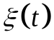.
We will understand such important statistical characteristics which are possible for calculating for any selected time series at once, without existence of any a priori knowledge of its character, and also without preliminary estimate of distribution function of that stochastic variable that is the cornerstone of the initial analyzed process as numerical characteristics of TS. It should be noted that, nevertheless, for calculation of most of them it is necessary to carry out initially an inspection of a time series on belonging to this or that class of TS. The most important is at the initial stage to define by statistical checks, the studied row is stationary or non-stationary. As we will see further, the majority of estimates of numerical characteristics of a row relies on a concept of ergodicity, and such nature of accidental processes does not exist within non-stationary time series.
From definition of an accidental processes stationary in a broad sense (namely we will work with them before studying of adaptive methods of the analysis of TS) follows that expectation value and dispersion/variance of the selected row do not depend on the choice of starting point of counting. Then these important characteristics of a time series can be evaluated on the basis of strict theoretical determinations of these values for random series, taking into account their description in a discrete form in the form of counting of a temporary grid. Many other important characteristics of time series rely on so-called initial and central the statistical moments of n-order which depend on determination of an expectation value and variance. For this reason we will begin with them.
With strict definition, expectation (mean) value оf any deterministic 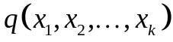 of k stochastic arguments, denoted as 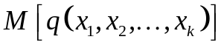 and also defined as follows:
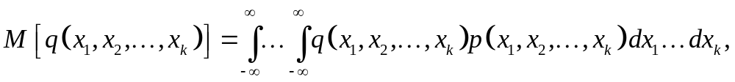 (2.1)
where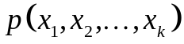 – k-dimensional density probability. Operation M[…] means ensemble averaging of samples and represents integration on the range of possible values of stochastic variables taking into account probability of obtaining this value.
Expression (2.1) looks much more simple for one-dimensional probability density:
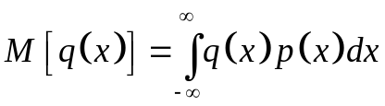 (2.2)
Mathematical expectation (2.1) is the initial moment of first order. For introduction of the initial moments of n-order expression of a type is used:
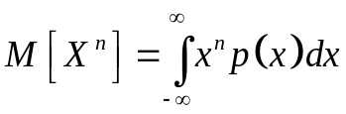 (2.3)
The central moments of n-order are defined similarly:
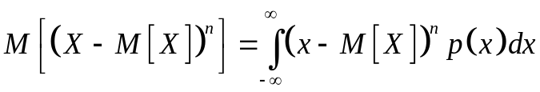 (2.4)
First initial moment (expectation (mean) value) characterizes the center of dispersion of data, and the second central moment (variance/dispersion) – the value of dispersion of data.
Expressions (2.1) – (2.4) in itself are already rather applicable in practice, but the problem consists that TS is only private selection of an stochastic variable. Therefore here it is necessary to use the concept of ergodicity entered in the first lecture which allows to pass from averaging on implementations to averaging on one rather long implementation (i.e. on time). Then for determination of a mean value 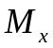 ergodic accidental processes it is possible to use expression (2.5), and for a variance 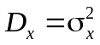 – (2.6):
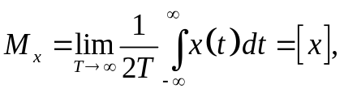 (2.5)
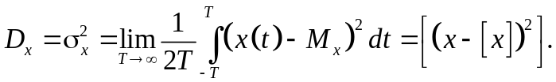 (2.6)
Here operation [..] is already a time averaging, and not on ensemble.
It should be noted that all initial moments including expectation value change at addition to a stochastic variable of permanent composed. The central moments to which dispersion belongs depend on the selected units of measure. To eliminate these defects often time series initially normalize.
Any time series by determination is presented in a discrete form and has a limited time frame. Taking into account these features, the initial and central moments are not calculated according to (2.3) – (2.6), but instead evaluated through discrete approximations.
Expectation (mean) value can be evaluated by simple averaging of all values:
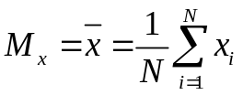 (2.7)
where 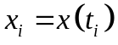 – analyzed time series, N – number оf observations or length of time series data.
Variance assessment often is made with a formula:
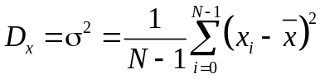 , (2.8)
which is the least sensitive to a rounding-off error.
Calculation formulas of the initial and central moments of n-go of an order are similarly sampled. Among the statistical moments of a high order it is necessary to select two important rated points: asymmetry of a (third central moment) and e excess (fourth central moment):
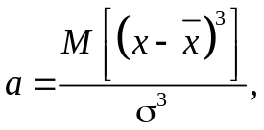 (2.9)
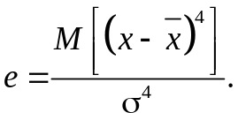 (2.10)
Asymmetry characterizes asymmetry of distribution of an aleatory variable, and an excess – degree of expressiveness of the tails of distribution, that is frequency of emergence deleted from a mat. expectations of values. Zero asymmetry testifies to symmetry of the distribution which is the cornerstone of TS. If the excess of any distribution surpasses that of a Gaussian (thus larger than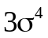), it indicates the considerable number о data with big amplitudes. Such "tails" of distribution of random check are considered "thick", in comparison with normal distribution.

Part 2. Correlation characteristics of time series
Like the description of the central and initial moments from the first part, all correlation characteristics of time series are initially entered theoretically for some stochastic variables with given density function p(x). Let's present that we have two stochastic variables of X and Y, generating some time series. A covariance of these X and Y stochastic variables is:
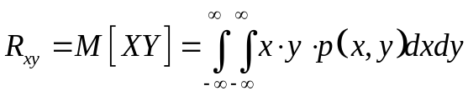 (2.11)
From expression (2.11) it is visible at once that if mean values of these stochastic variables are other than zero, then value of covariance can «departure» from the expected value. Therefore in practice use the centered version of the covariance called the correlation (2.12). At zero average a concept of covariance and correlation are equivavlent.
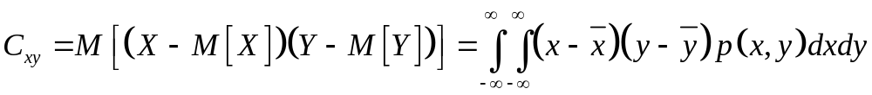 (2.12)
Correlation and covariance of two stochastic variables shows degree of linear dependence of these values from each other. If stochastic variables are values of the same accidental process (that actually and occurs in practice, as values of its determination selected by single TS), then the specified functions (2.11) and (2.12) become autocovariation (2.13) and autocorrelation (2.14) functions.
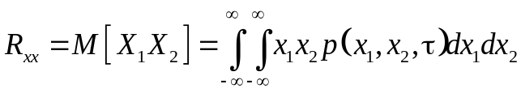 , (2.13)
(2.14)
These statistical functions characterize a measure of statistical dependence of values of one stochastic variable shifted relatively each other on τ time interval.
Similar to formulas from the first part, we will lead expression (2.14) to its practical discrete form, taking into account properties of ergodicity and stationarity investigated by TS, and also taking into account the final duration of selection of a row. Let there is some number of Y(t), from it we choose two sequences 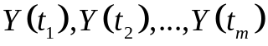 и 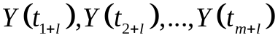, shifted relatively each other on l of instants, that is with l lag. Then assessment of autocorrelation function will be described in a general view:
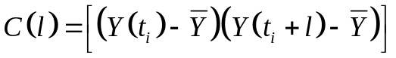 (2.15)
where operation [..] is a time averaging, used similar to expression (2.7) earlier.
Let's note some important properties of autocorrelation function. First о all, for a stationary time series the value (2.15) depends only on lag l, at this 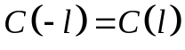, thus making it OY axis symmetric, therefore it is enough to construct autocorrelation function only for 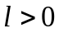 . Secondly, at 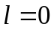, it is easy to notice that expression (2.15) will turn into dispersion definition, that is 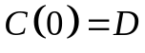. Thirdly, at the same time 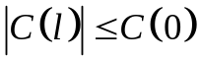 for any given value оf lag l. Fourthly, that rather important for time series analysis if initial accidental process contains some periodic component, then autocorrelation function 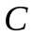 will also be periodic. If such periodic components are not present within data, then 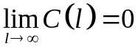.
In practice, for assessment of quantitative degree of interrelation between values of the same implementation of accidental process (that is counting same TS) taking into account the properties stated above for autocorrelation function and , it is much more convenient to normalize it:
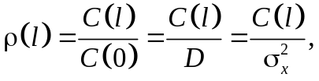 (2.16)
called as an autocorrelation coefficient.
Let's define properties of this coefficient similarly described above for autocorrelation function. It is obvious that 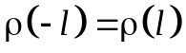, 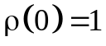, 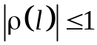.
Taking into account expressions (2.15) and (2.16) we will write final assessment of a sample autocorrelation coefficient:
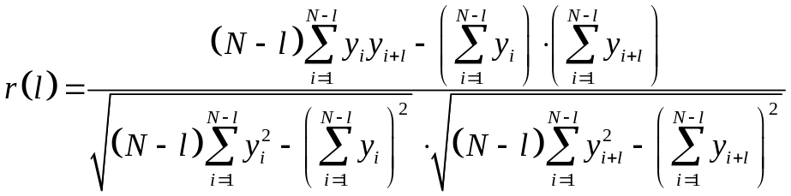 , (2.17)
where 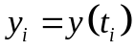 – the analyzed time series, N – number о observation or the length о time series data, l – a lag. Let's notice that with increase in l the number of observations in calculations is reduced therefore l should not be big (usually it is enough for 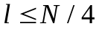).

Part 3. Autocorrelation function analysis
Let's note important properties of autocorrelation function and autocorrelation coefficient which will be useful to us further in the analysis of the TS.
First, for stationary of TS with increase in a lag l the interrelation of counting weakens, and absolute values of autocorrelation coefficient 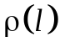 (2.16) have to decrease. This very important property, which just in to this or that form it is used in statistical tests for check of TS for stationarity. At the same time it is necessary to understand that assessment of selective coefficient of 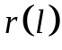 (2.17) can break property of monotonous decrease, especially at small N-l values. It turns out that shorter ranks with much bigger probability will be non-stationary.
Secondly, on the value of autocorrelation coefficient it is possible to judge existence linear (or close to it) tendencies of development of TS as weight factors at creation of autoregressive models depend on it.
Thirdly, on a sign of autocorrelation coefficient it is impossible to draw conclusion about the increasing or decreasing trend of TS. Between them there is no communication, however the similar delusion is widespread in practice.
Sequence of autocorrelation coefficients 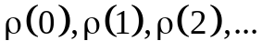 would be called autocorrelation function of TS, and, the diagram of dependence from lag l – correlogram о TS. Analyzing these two characteristics, taking into account all above-mentioned properties of function of autocorrelation, it is possible to reveal structure investigated by TS in compliance with additive model (1.3), that is existence in it of a trend, seasonal components and periodic components.
Let's list the most important outputs from all listed properties and definitions:
- If the first autocorrelation coefficient 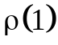is the highest, that investigated by TS contains a trend in the basic. In a different way of speak, that the trend covers the greatest percent of dispersion in initial TS. Simple language, in the analyzed row the trend is best of all visible, on its background the periodical press is not so well noticeable. But it does not mean that there is no periodical press at all there. Just without removal from initial TS trend (and it is possible) to look for it for additive model seasonal and cyclic components it will be very difficult.
- If the autocorrelation coefficient is the highest, than a TS contains fluctuations with period of 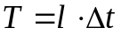.
- If none о the coefficients are significant, than ther can be two assumptions: in a row there is neither trend, nor the periodical mode, and its character is close to a white noise; or there is a nonlinear trend which hides all other components from the observer.

Part 4. An example
Let's review an example of application of an analysis technique of TS on the basis of creation of its correlogram and assessment of sample autocorrelation function. Let it is set by TS which values on columns are given in table 2.1. This row is also represented in the figure 2.1.
Table 2.1.
The time series containing values of an output of a batch of chemical process
1-7 | 8-14 | 15-21 | 22-28 | 29-35 | 36-42 | 43-49 | 50-56 | 57-63 | 64-70
47 | 41 | 58 | 57 | 25 | 58 | 45 | 52 | 34 | 60
64 | 59 | 44 | 50 | 59 | 45 | 57 | 38 | 35 | 39
23 | 48 | 80 | 60 | 50 | 54 | 50 | 59 | 54 | 59
71 | 71 | 55 | 45 | 71 | 36 | 62 | 55 | 45 | 40
38 | 35 | 37 | 57 | 56 | 54 | 44 | 41 | 65 | 57
64 | 57 | 74 | 50 | 74 | 48 | 64 | 53 | 38 | 54
55 | 40 | 51 | 45 | 50 | 55 | 43 | 49 | 50 | 23

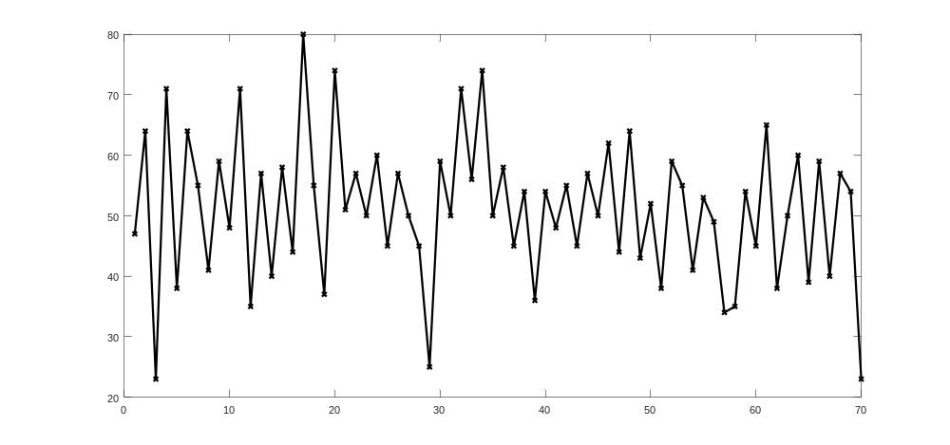
Figure 2.1 – An initial time series on the basis of table 2.1

Let's construct a correlogram of this time series. For this purpose we will make calculation of assessment of sample autocorrelation function for formulas (2.16) and (2.17). The turned-out sample autocorrelation function from a log is given in fig. 2.2 below.

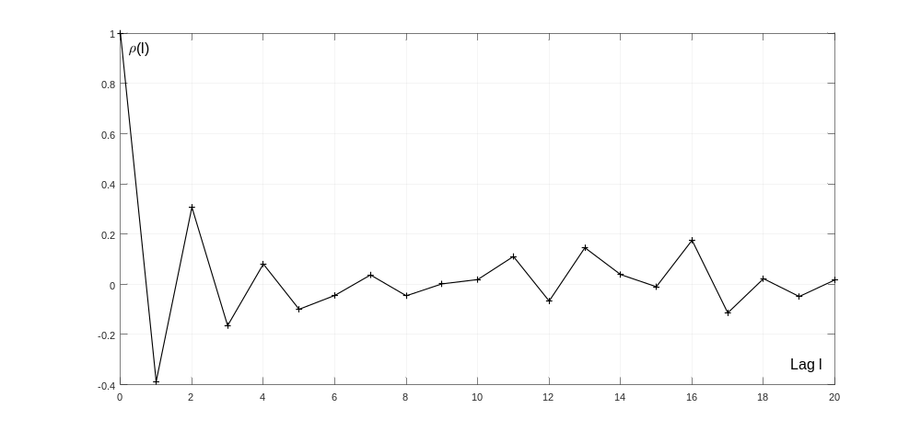
Figure 2.2 – Autocorrelation function of TS from the figure 2.1

From the figure 2.2, that is a correlogram, it is possible to draw several conclusions. First, sample function of autocorrelation is sign-variable with a tendency to attenuation in process of growth of a log/delay. At the same time attenuation is not absolute therefore a row cannot be carried unambiguously to stationary TS. Secondly, the greatest value on the module ρ(1) has, and, so in a row there is a trend which occupies a considerable share of all its structure. Apparently from the figure 2.3, approximate estimates of a trend line issue its decreasing character. Thirdly, after the first log 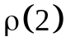 coefficient has the highest value. It means that for each point through one some dependence is observed. Really, if to pay attention on TS, its values often "jump" through one point: high values with low, the so-called "oscillating" time series. Sign-variable autocorrelation also confirms it.
In general, on the example of this row it is possible to draw conclusion that the method of the analysis of TS relying only on assessment of sample autocorrelation function is not good and effective solution. Really, it is possible to draw many drawn conclusions on the nature of TS just looking at an initial row. In it there is also the main lack of a method of autocorrelation function – it will not be able to show that it is hidden in the studied time series from the observer. But in same and its benefit – everything that is obvious at visualization of an initial row, will be confirmed with its assessment to sample autocorrelation function. And all false system features of a row which seemed to the person in the analysis of TS “approximately”, will be cut by such approach.

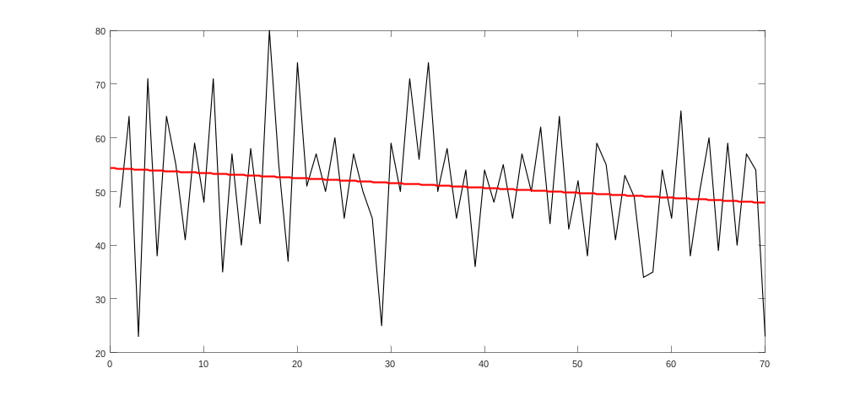
Figure 2.3 – Initial time series and its estimated linear trend

As we will see further, assessment of selective autocorrelation belongs to the class of nonparametric methods which can be applied only to the analysis stationary by TS as all activity definitions of averaging are formulated taking into account property of ergodicity. Moreover, in practice even for stationary TS cycles can have the period floating near some mean value. Assessment of selective autocorrelation is under construction we here will not receive only from fixed values of a delay/log, and dependences of the period on an instant in any way. For receiving, so-called, time-and-frequency characteristics of a row, that is dependences of the period/frequency on time, we will need a new class of the adaptive methods which are not demanding from the initial existence of stationarity analyzed by TS even in a broad sense this determination.

References

1. Box G., Jenkins G. Time Series Analysis: Forecasting and Control. — 4th ed. Wiley. — 2008. — 784 p.
2. David R. Brillinger. Time Series: Data Analysis and Theory. — SIAM. — 2001. — 540 p.
3. George A Duckett. Time Series Analysis: Questions and Answers. — CreateSpace Independent Publishing Platform. — 2016. — 258 p. ISBN 978-1-533-57098-7.

